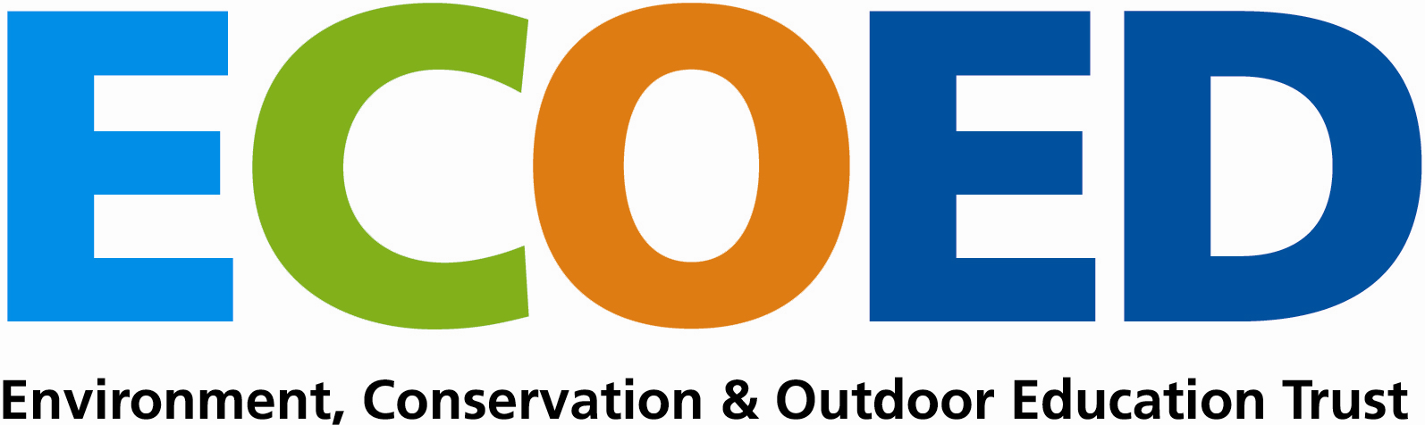
Act
Reflect
Choose
Context and Environment for Learning

Indicators for Success Evaluation Where to from here?

Appendix 3b: ECOED TEMPLATE TO ASSIST OVERVIEW PLANNING FOR CROSS CURRICULAR PROGRAMMES
Selected Curriculum Objectives to Achieve Learning Outcomes

Knowledge and Understanding:
What do we want students to know and understand?
Skills and Key Competencies:
What do we want students to be able to do?
Attitudes and Values:
What attitudes and values do we want students to develop and demonstrate?
Actions:
How do we want students to act?
Concepts and Principles:
What concepts and principles do we want students to discuss and develop understanding of?

Suggested Experiences to Achieve Learning Outcomes

Learning Resources

